**Project Plan**

***RealtyHub***

*Client: HouseHunter*

|  |
| --- |
| **Date : 16.02.2023** |
| **Version :** |
| **State : Ongoing** |
| **Author : Radu Andrei Popescu** |

#### Version history

|  |  |  |  |  |
| --- | --- | --- | --- | --- |
| **Version** | **Date** | **Author(s)** | **Changes** | **State** |
|  |  |  |  |  |
|  |  |  |  |  |
|  |  |  |  |  |

**Distribution**

|  |  |  |
| --- | --- | --- |
| **Version** | **Date** | **Receivers** |
|  |  |  |
|  |  |  |

Contents

1. Project assignment 3

1.1 Context 3

1.2 Goal of the project 3

1.3 Scope and preconditions 3

1.4 Strategy 3

1.5 Research questions and methodology 3

1.6 End products 4

2. Project organisation 5

2.1 Stakeholders 5

2.2 Communication 5

3. Activities and time plan 6

3.1 Phases of the project 6

3.2 Time plan and milestones 6

4. Testing strategy and configuration management 7

4.1 Testing strategy 7

4.2 Test environment and required resources 7

4.3 Configuration management 7

5. Risks 8

5.1 Risk and mitigation 8

# Project assignment

## Context

HouseHunter is a company that started in Eindhoven during the housing shortages in 2022. It provides wide variety of properties and apartments for both sale and renting. The company gained a lot of popularity after the display of amazing customer support and number of accommodations sold and rented within the first months. The company since then has started to grow exponentially.

## Goal of the project

This project is intended to make a software solution for HouseHunter so that they can sell and rent out more easily in response to the big demand from their clients. With this website they will be able to reach out to their clients more easily and advertise their properties. Realtors will be able to post their properties and choose whether they are for renting or buying and customers will be able to rent and buy the respective properties. The role of the admin will be the general management of the website and remove estates if they prove to be a scam or simply are outdated.

## Scope and preconditions

|  |  |
| --- | --- |
| **Inside scope:** | **Outside scope:** |
| 1. Creating, Updating, Viewing and Deleting functionalities for accommodations and estates | 1. Instructions and manual for using the website |
| 1. Creating different accounts for the respective roles | 1. Personal Computers for the staff |
| 1. Advertisements and new properties |  |
| 1. Reporting and issue |  |

## Strategy

For this project I will be using the Agile SCRUM methodology. With this approach, I will work on small parts of the project with continuous experimentation and feedback loops along the way to learn and improve my overall skills. The reason I chose this strategy for this project is because out of all the strategies I have worked with up until this point, Agile proved to be the most successful in terms of both end product and skills gained along the way and its methodology allows me to review and change past parts of the project if needed.

## Research questions and methodology

“What is the best programming language for this particular project ?”

The asnwer to this question is Java languange with the help of Lombok and Gradle. This cocnclusion was based on the methodology from teh ICT research method Literature Study. With teh help of materials provided by my teachers and institution I have come to the conclusion that Java would be most suitable for this website.

## End products

I have listed below all the products that I will deliver in this project to HouseHunter in a diagram. This includes both software solutions along with documents and tests.

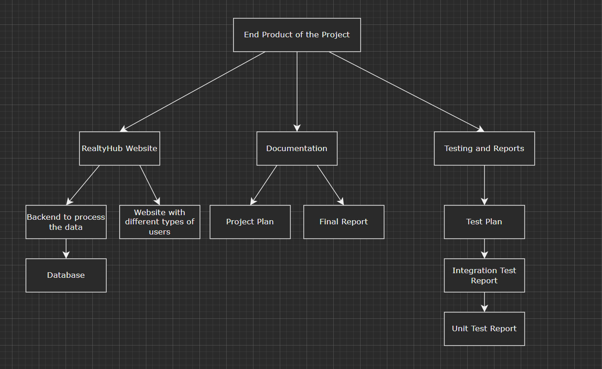

# Project organisation

## Stakeholders

The stakeholders of this project are the client, HouseHunter and myself. My name is Radu Andrei Popescu and I can be contacted at [raduandrei.popescu@student.fontys.nl](mailto:raduandrei.popescu@student.fontys.nl) or via MS Teams. Additionally, my tutors are Mrs. Roopali, Mr. Faruk and Mrs. Pesic.

|  |  |  |  |
| --- | --- | --- | --- |
| **Name** | **Abbreviation** | **Role and functions** | **Availability** |
| *HouseHunter client* |  | *Client* | *According their schedule* |
| *Radu Andrei Popescu* |  | *Programmer* | *Anytime from Monday until Friday* |
| *Gupta Roopali* |  | *Tutor* | *Monday-Friday 8.00-17.00* |
| *Pesic Maja* |  | *Tutor* | *Monday-Friday 8.00-17.00* |
| *Aydin Faruk* |  | *Tutor* | *Monday-Friday 8.00-17.00* |

## Communication

In this project I will hav 6 sprints in which I will present to the client the progress up to that meeting, Sprints will be conducted every 20 days and will be a means to show the progress of both the application and my skills. These meetings will be in person, along with meetings with my tutors that will be weekly. For further communication, we will use MS Teams or Outlook. For myself, I will use Trello for managing my tasks.

# Activities and time plan

## Phases of the project

As stated above, following the Scrum methodology for this project, I will abide by the framework instructions. The sprints will consist of:

* Requirements analysis
* Product backlog
* Update the sprint backlog
* Implementing the sprint backlog
* Testing the sprint
* Sprint review + retrospective

## Time plan and milestones

*For an agile project, describe how the artefacts are planned. E.g., length of sprint (with justification), organization of stand up, demo, retrospective.*

*>>*

|  |  |  |  |
| --- | --- | --- | --- |
| **Phasing** | **Effort** | **Start date** | **Finish date** |
| 1. Sprint 1 | ?/10 | 17/02/2023 | 3/03/2023 |
| 1. Sprint 2 | ?/10 | 3/03/2023 | 24/03/2023 |
| 1. Sprint 3 | ?/10 | 24/03/2023 | 14/04/2023 |
| 1. Sprint 4 | ?/10 | 14/04/2023 | 12/05/2023 |
| 1. Sprint 5 | ?/10 | 12/05/2023 | 3/06/2023 |
| 1. Sprint 6 | ?/10 | 3/06/2023 | 23/06/2023 |

# Testing strategy and configuration management

## 

## Testing strategy

|  |  |  |
| --- | --- | --- |
| Testing envision | Percentage code coverage | Available automation |
| Unit testing | 30% | N/A |
| Acceptance criteria | N/A | Automation available |
| Component testing | N/A | N/A |
| Integration testing | N/a | N/A |

After extensive research I have decided that the most relevant types of testing that must be looked upon are unit tests and acceptance criteria. I plan to expand onto component testing where I want to get an overview of the UI (user interface) workflow and functionality.

The goals for this project are to test the most relevant functionality and avoid redundancy. My defined goals are to have proper component testing and show only the most relevant results.

## Test environment and required resources

I have decided to use CI/CD environment as a test environment on Gitlab because this allows me to receive and respond to customer feedback much faster than before. Updates

could be deployed and made live for the user in as little as just minutes after the developer

has written the code.

I have used a DTAP(Development, Testing, Acceptance, Production) environment for the

project. This picture describes the CI/CD environment of the project.

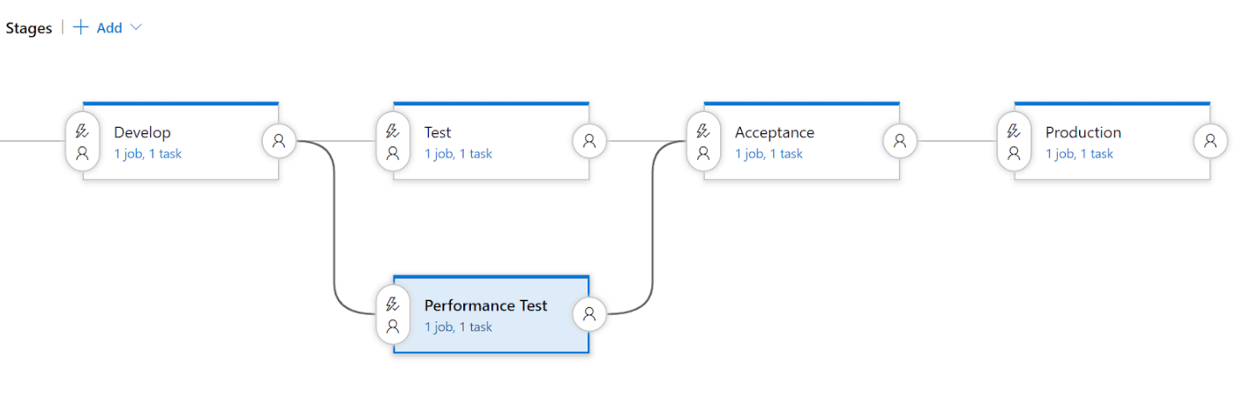

After researching the best way to test, it has been found that Unit-testing, integration test and

acceptance test are the most relevant tests to use for the project to identify errors, gaps, or

missing requirements of the project.

## Configuration management

**What is continuous integration?**

GitLab CI (Continuous Integration) service is a part of GitLab that builds and tests the software whenever the developer pushes code to the application. GitLab CD (Continuous Deployment) is a software service that places the changes of every code in the production which results in every day deployment of production.

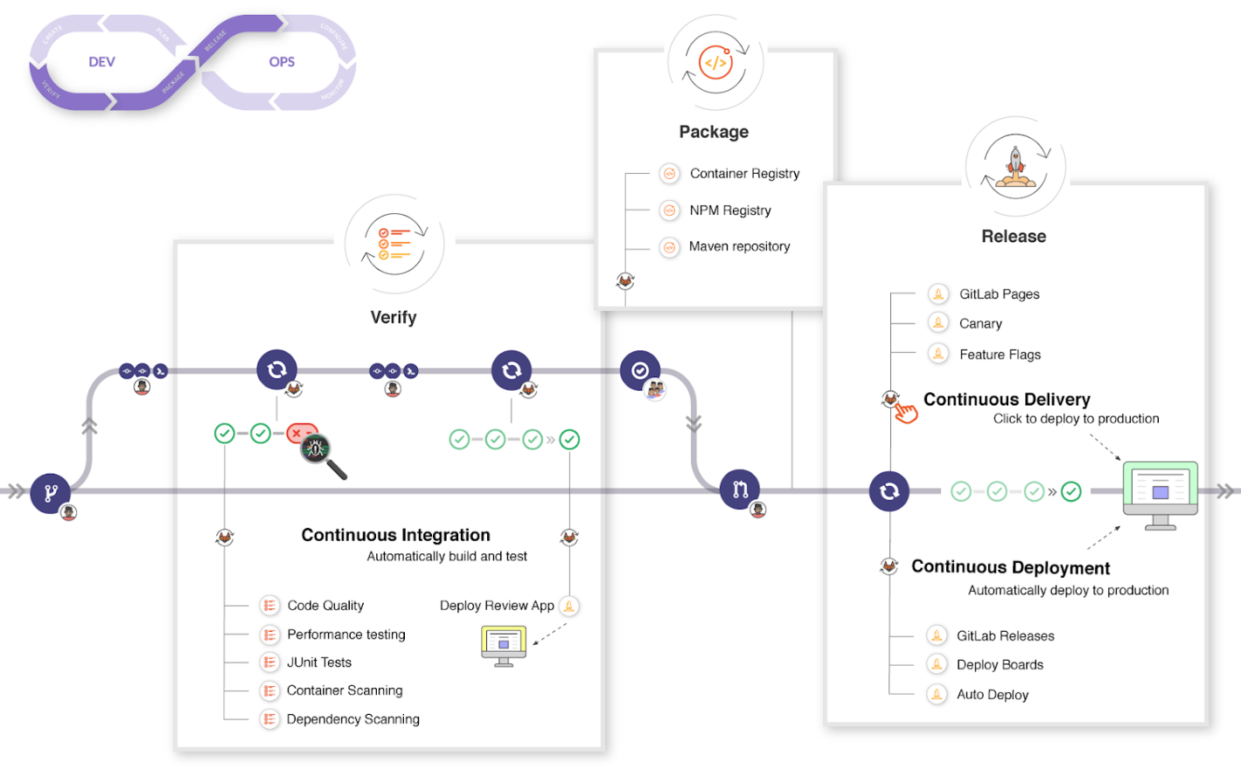

**Why did I decided to use GitLab for this project?**

GitLab is a web-based DevOps lifecycle tool that provides a Git repository manager providing wiki, issue-tracking and continuous integration and deployment pipeline features, using an open-source license, developed by GitLab Inc.

I think GitLab is a professional environment and has many advantages that help with configuration and file management. I plan to keep everything up to date and provide the necessary commit labels for better storing.

# Risks

## Risk and mitigation

|  |  |  |
| --- | --- | --- |
| **Risk** | **Prevention activities** | **Mitigation activities** |
| 1. Incomplete Requirements | Getting a clear set of requirements before starting to work on the project and keep in contact with the client if there is a misunderstanding. | Contact the client in regard to the requirement in question. |
| 1. Scope Creep | Keep the changes to a minimum. | Remove or do not implement changes that are not a priority. |
| 1. Inadequate testing | Test every feature that has been implemented. | Try to find a solution as soon as possible. |
| 1. Dependency Management | Make sure all technologies and software are compatible with each other | Update the respective software or lend equipment suitable for your needs. |
| 1. Lack of documentation | Make sure all documentation has been kept updated. | Update the documentation. |